**LEBANESE AMERICAN UNIVERSITY**

**USAID – HIGHER EDUCATION SCHOLARSHIP PROGRAM**

**HES - Volunteering Program Verification Form**

This form is to be used to document volunteering hours. If a student volunteers for multiple organizations, a separate form must be used for each organization. **This form must be turned in by the 28th of each month, the latest.**

I certify that the scholar Ranim Ibrahim completed a total of 5 hours of service at InnovaThrive.

The hours were completed hours as per the below:

Hours # 5 (date) _2/12 – 6/12_ (initials of supervisor) __A.K.___

Hours # 0 (date) _9/12 – 13/12_ (initials of supervisor) __A.K.___

Hours # 0 date) _16/12 – 20/12 (initials of supervisor) __A.K.___

Hours # 0 date) _23/12 - 27/12 (initials of supervisor) __A.K.___

Brief description of the activities the scholar performed or participated in:

I researched the topic of Artificial Intelligence and Predictive Analytics in Healthcare. I looked up its definitions, key technologies, studied some real life examples and the topic's statistics. I then delved into its advantages and disadvantages, challenges, and finally about future research related to Artificial Intelligence and Predictive Analytics in Healthcare.

Written feedback about the scholar’s performance:

Ranim Ibrahim’s research on Artificial Intelligence and Predictive Analytics in Healthcare was well-organized and insightful. However, the volunteering form was submitted late, which is unacceptable. Meeting deadlines is essential for the success of the program, and timely submission in future tasks is expected.

Please rate the overall performance of the scholar at your organization:

|  |  |  |  |
| --- | --- | --- | --- |
|  | Mastery (5) | Proficient (3) | Emerging (1) |
| **Problem solver** | X |  |  |
| **Engaged & Committed** | X |  |  |
| **Open-minded & multicultural** | X |  |  |

Signature

& stamp

__________________________

_

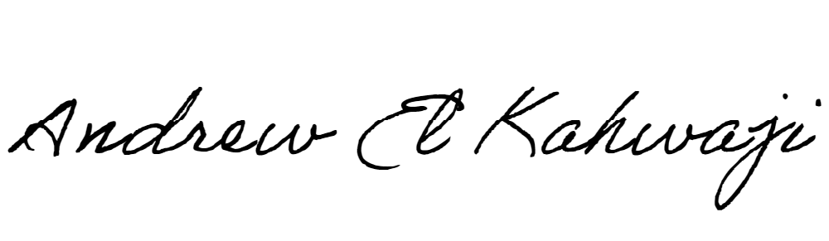

Printed Name _Andrew El Kahwaji_

Date __26/12/2024___

Email __andrew.lifesculptor.coo@gmail.com __

Phone __+961 71 914 378__